MusicDBExercise_FormAndBusinessRules

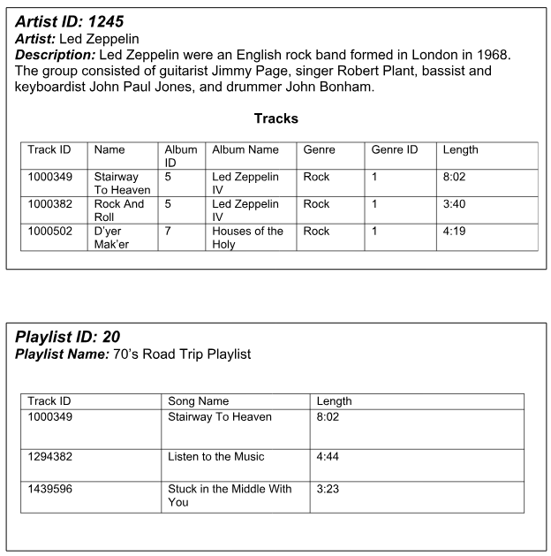

Business Rules:

* TrackIDs are unique for each track
* Multiple artists can have the same song name, but TrackID would still be unique
* Each album has only one artist
* An album can have tracks of different genres
* Album ID 1 can appear for many artists, but each artist has only one album with an ID of 1
* Tracks can appear in multiple playlists
* A playlist can have multiple tracks